**(صف تاني)Second Line**

**Target:**

The fastest and easiest way to reach the owner of the car (the one parked in a second line)

**No solution of this problem :**

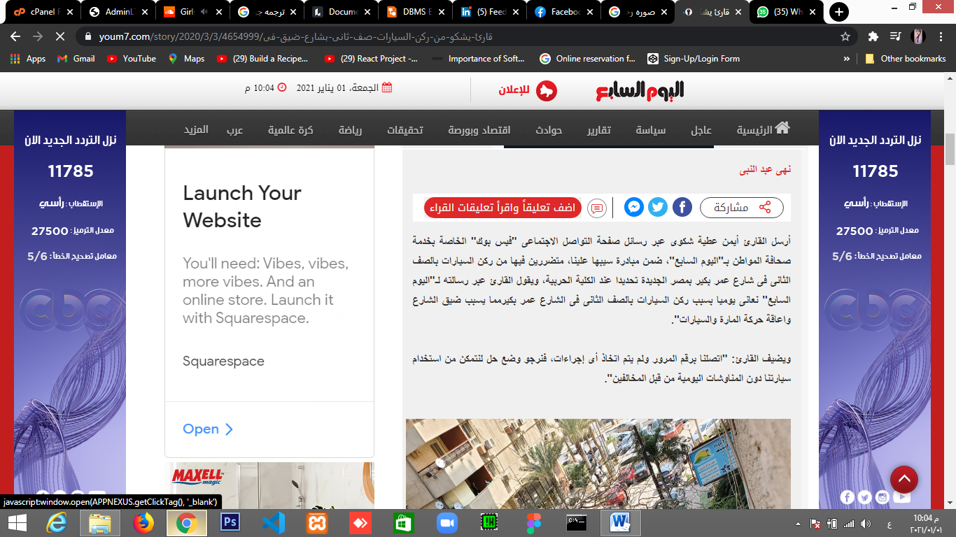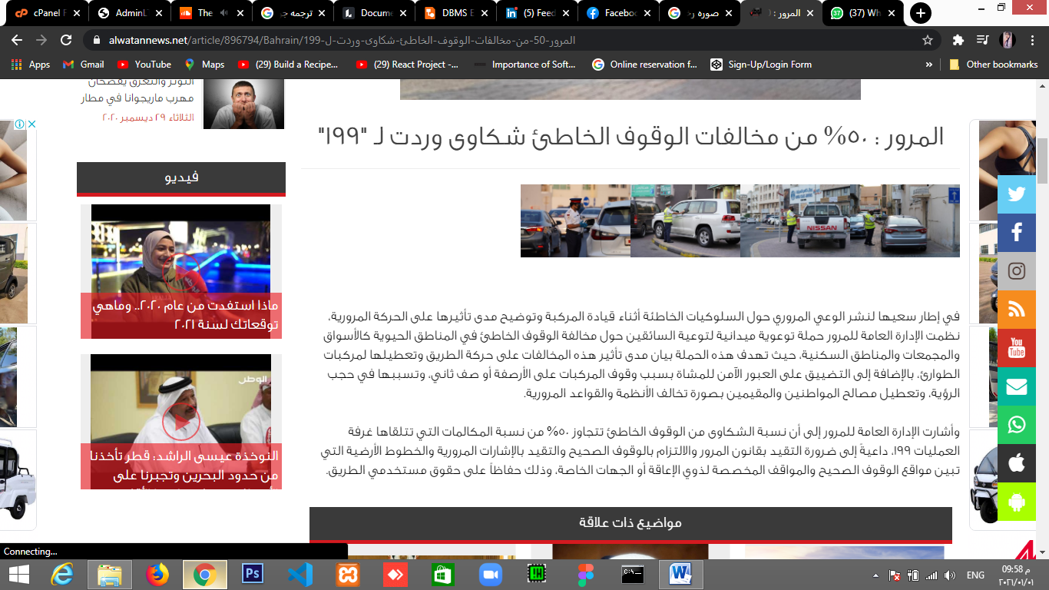

Knowing the car's owner:

UML digram